**The @font-face Rule**

The **@font-face**  rule allows custom fonts to be loaded into a webpage.   
With the help of this rule, designs are no longer limited to the fonts that are installed on a user's computer.   
In Internet Explorer 8 and earlier, the URL must point to an **Embedded OpenType** (eot) file, while Firefox, Chrome, etc. support **True Type Fonts** (ttf) fonts and **OpenType Fonts** (otf).

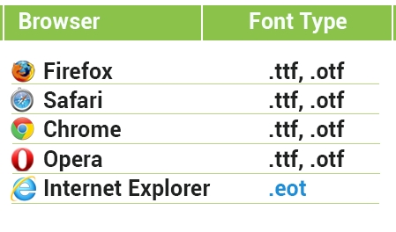

**Using the @font-face Rule**

Each form of the font family must be declared using the **@font-face** rule. In the example below, a custom font called "Delicious" is loaded and used for the heading.  
  
**The HTML**<h1>This is Our Headline</h1>  
**The CSS**

@font-face {  
font-family: Delicious;   
src: url('Delicious-Roman.otf');   
}   
@font-face {   
font-family: Delicious;   
font-weight: bold;   
src: url('Delicious-Bold.otf');   
}  
h1{  
font-family: Delicious, sans-serif;   
}

Internet Explorer has a built-in bug when multiple @font-face rules are defined. Using **#iefix** as shown below fixes the problem:@font-face {   
font-family: Delicious;   
src: url('Delicious-Roman.ttf');  
src: url('Delicious-Roman.eot**?#iefix**');   
}

The question mark fools IE into thinking the rest of the string is a query string and loads just the EOT file. The other browsers follow the spec and select the format they need, based on the src cascade.